**A Brief Research Report of Airbnb in Seattle**

<https://travel.rakuten.co.jp/mytrip/amazing/yakei-tokyo>

When you want to spend a relaxing vacation in Seattle, Airbnb is becoming an increasingly popular choice. When you are hesitating among various choices, which factors are key to making your choice. Avoiding high price periods? The rating of the host? The environment and sanitary conditions of the accommodation? Or the convenience of procedures?

On the other side, as the host of the accommodation, understanding the preferences of the guests and analyzing the rivals is the key to improve the profitability.

An analysis of Seattle Airbnb's data in 2016 will help Airbnb hosts in Seattle better understand what factors influence the price of Airbnb in Seattle and hope to help to increase their income.

**What is the busiest times of the year to visit Seattle? By how much do prices spike?**

First, let’s take a look at the busiest time of the year to visit Seattle and how prices move.

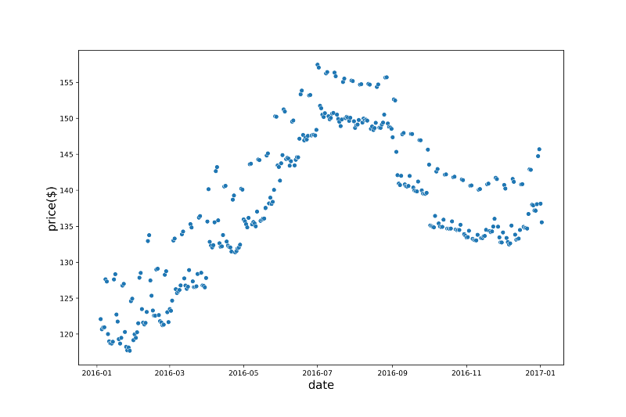Daily price changes over time.

The figure above shows the price movements over a full year. From it we can see that prices start to rise from January until July, when they reach their peak, and July to September is the highest time of the year. From January to July, the total increase is about $30, and the average increase is about $5 per month. Prices fell slightly after this period, but still trended upward from December.

July to September is the summer vacation period, so more people choose to spend a leisurely vacation in Seattle, which is why the price increases during this period.

From the figure above, we can also see that regardless of the period, the prices show a distribution, i.e. there are a few days in the week when the prices are $5–10 higher. So let’s look at the change in the average price for each day of the week.

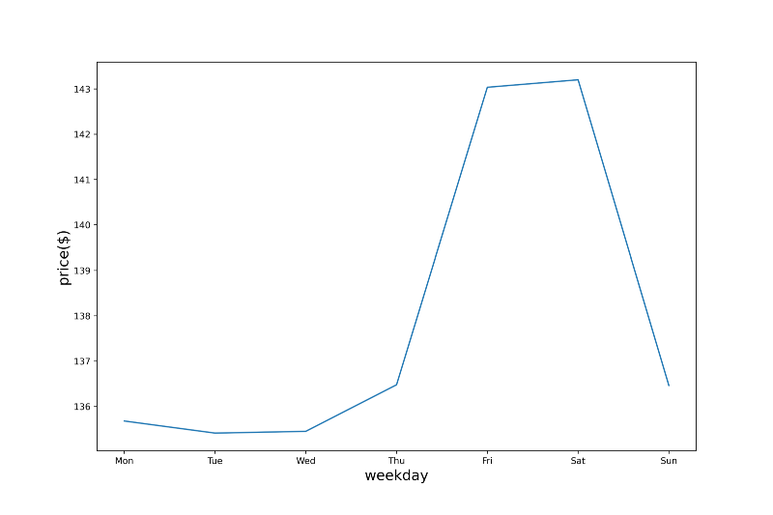The change of the average price in Seattle with the day of week.

Sure enough, the average price on Friday and Saturday of the week was $5–10 higher than the rest. which is understandable since everyone starts their week off on Friday night.

**What factors have a relationship with the price of Seattle Airbnb?**

Next let’s look at how Seattle Airbnb prices relate to the neighborhood.

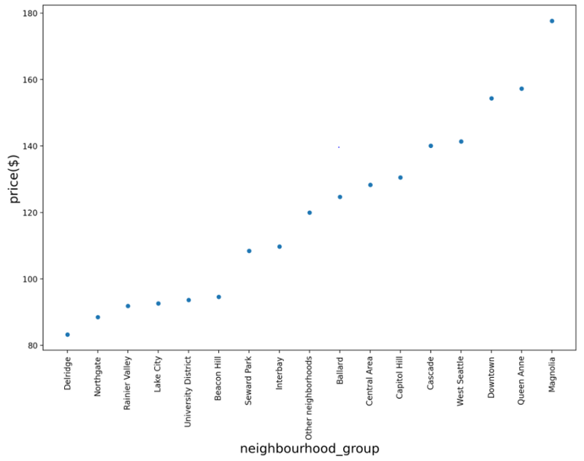The relationship between the neighborhood group and the average price in Seattle.

From this graph above we can observe that the average price of Airbnb in Seattle shows a very clear regional pattern. The top 3 highest prices are Magnolia, Queen Anne, Downtown and the top 3 lowest prices are Delridge, Northgate, Rainier Valley. The price difference is about $70-100. Obviously, some areas closer to the city center or popular tourist areas are generally more expensive.

Then let’s look at the relationship between review scores ratings and prices.

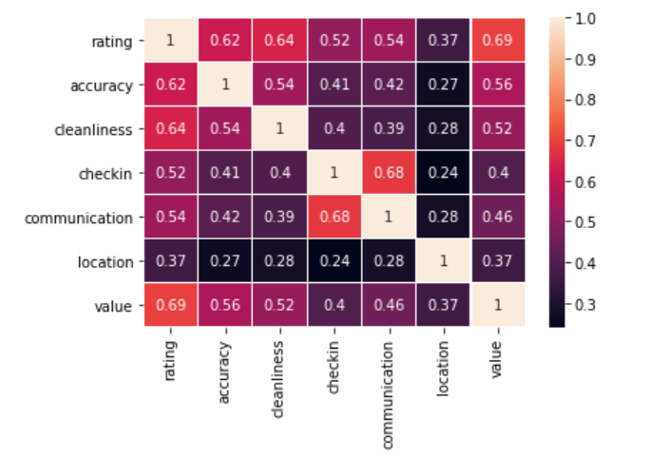

The correlation of review scores rating and its detailed items.

The rating data has an overall rating — review scores rating (out of 100) — and some minor items — accuracy, cleanliness, checkin, communication, location and value (out of 10).

By correlation analysis, i.e., the larger the value in the graph, the greater the correlation, we can see that review scores rating has the largest correlation with values (0.69), followed by cleanliness (0.64), and the smallest correlation with location (0.37). To some extent, this reflects what factors customers are more concerned about. Improving the value and sanitary conditions of the accommodation may be effective in earning a high review scores rating and even gaining more repeat customers.

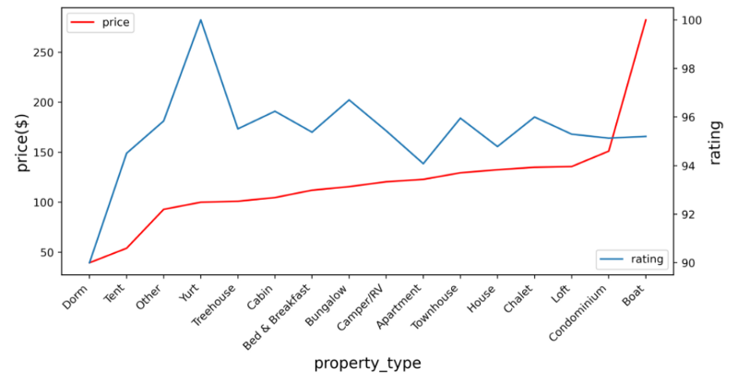The relationship of the property type with the review scores rating and the average price in Seattle.

How about the property type? The figure above shows the relationship between various property types and prices, review scores ratings. The boat shows an extreme high price, which is more than twice than other property type. The other property types, except for Dorm and Tent, are priced more evenly between $100-$150.

As for the rating, except for Dorm who showed a minimum rating of 90 and Yurt who showed an extremely high rating close to 100, the ratings of the other property types were relatively average, all between 94–96. Here, we can visually see that yurt is not expensive but has a relatively high rating.

Finally, let’s look at the relationship between room type and review scores ratings, prices.

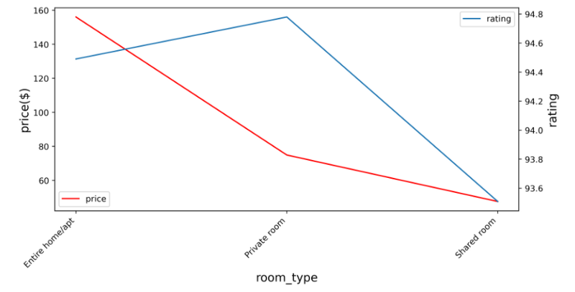The relationship of the room type with the review scores rating and the average price in Seattle.

As we can see from the figure above, the price of entire home/apt is about $150, which is twice as high as private room and three times as high as shared room. However, the rating of entire home/apt is slightly inferior to private room, and the rating of shared room is the lowest.

**Conclusion**

Through the above analysis, we can get the following conclusions.

1. July to September is the busiest period for Airbnb in Seattle, and prices are about $30 higher than in January and February, which is probably related to summer holidays. And no matter what the period is, weekend rates are $5–10 higher than weekday rates.
2. City centers and popular tourist spots are generally more expensive, averaging $70–100 more than the lower priced places.
3. Improving the value and sanitary conditions of the accommodation may be effective in earning a high review scores rating and even gaining more repeat customers.

**Acknowledgement**

This study is a part of a project in Udacity Data Scientist Nanodegree